# Algebra 2 – Unit 1 Linear Functions and Inequalities

# Name: ________________________________ Date: ________________ Period: _______

# Lesson 1.03 - Domain and Range Notes

|  |  |  |
| --- | --- | --- |
| **Inequality** | **Verbal Description** | **Is it true?** |
|  |  | Can x be10?  YES |
|  | Can x be 10? |
|  | Can x be 25? |
|  | Can a be .25? |
|  | Can h be 0? |
|  | Can y be 8? |
|  | Can t be 20? |
|  | Can x be -100? |
|  | Can x be 11? |
|  | Can x be 22? |

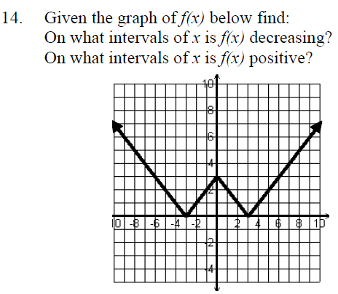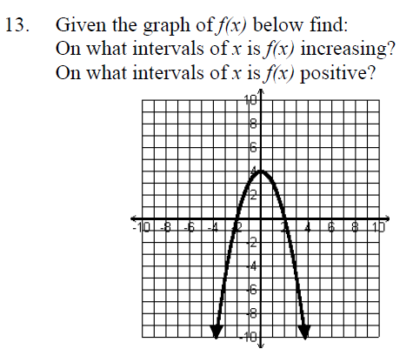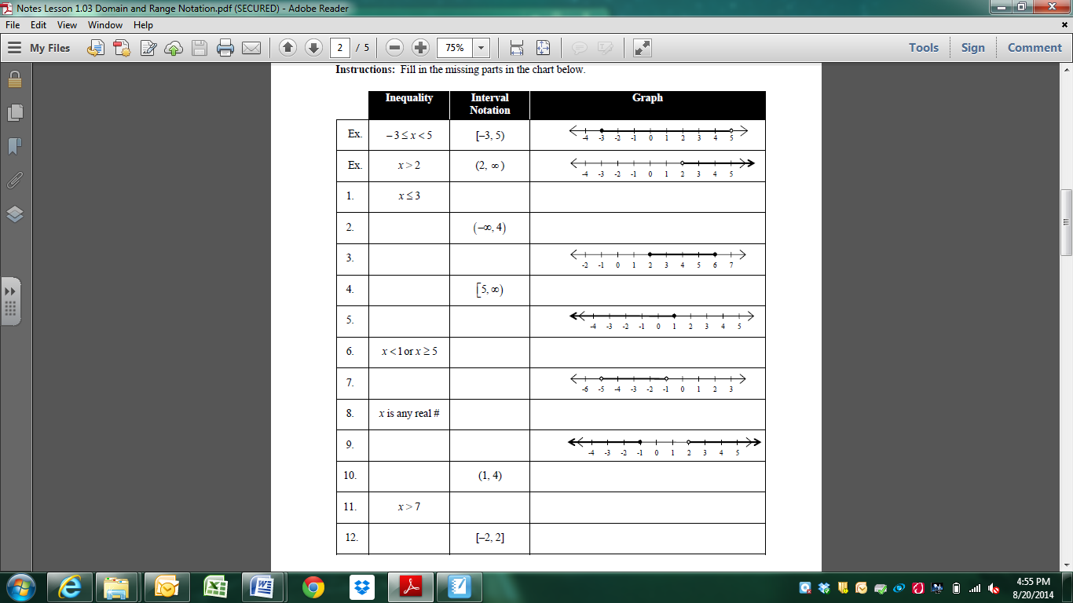

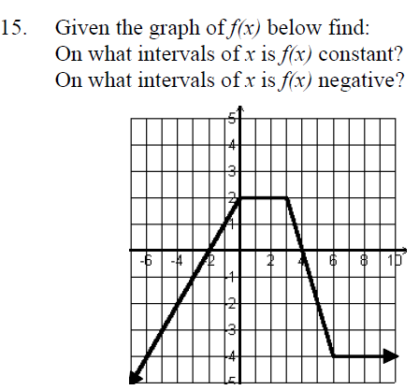

Use the graphs on the last page of the notes to fill in the table below.

|  |  |  |  |  |
| --- | --- | --- | --- | --- |
|  | **DOMAIN** | | **RANGE** | |
|  | Inequality Notation | Interval Notation | Inequality Notation | Interval Notation |
| 1. |  |  |  |  |
| 2. |  |  |  |  |
| 3. |  |  |  |  |
| 4. |  |  |  |  |
| 5. |  |  |  |  |
| 6. |  |  |  |  |
| 7. |  | |  | |
| 8. |  | |  | |



1

3

2



6

5

4



7

8

Which examples above are functions? Which of the graphs are continuous?

Which of the graphs above are discrete?